**DIAGRAM**

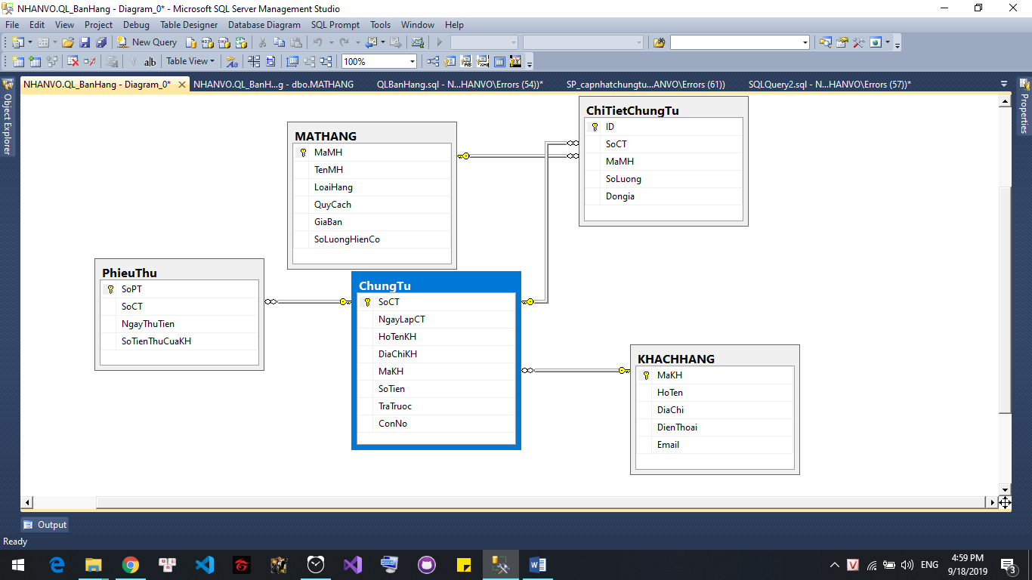

--Câu 2 : Sp_MatHang

ALTER PROC SP_MatHang

(

@MaMH int,

@TenMH nvarchar(250),

@LH nvarchar(50),

@QC nvarchar(50),

@GB decimal(18, 0),

@SLHC int

)

AS

BEGIN

DECLARE @Result INT = 0

BEGIN TRAN

BEGIN TRY

IF(EXISTS(SELECT * FROM dbo.MATHANG WHERE MaMH=@MaMH AND TenMH = @TenMH))

BEGIN

SET @Result =2

UPDATE dbo.MATHANG

SET LoaiHang =@LH,

QuyCach = @QC,

GiaBan = @GB,

SoLuongHienCo = @SLHC

WHERE MaMH = @MaMH AND TenMH = @TenMH

END

ELSE

BEGIN

INSERT INTO dbo.MATHANG

( TenMH ,

LoaiHang ,

QuyCach ,

GiaBan ,

SoLuongHienCo

)

VALUES ( @TenMH , -- TenMH - nvarchar(250)

@LH , -- LoaiHang - nvarchar(50)

@QC, -- QuyCach - nvarchar(50)

@GB, -- GiaBan - decimal

@SLHC -- SoLuongHienCo - int

)

--( [MALOAIHANG], [TENLOAIHANG] )

SET @Result =1

END

COMMIT TRAN

END TRY

BEGIN CATCH

PRINT ERROR_MESSAGE()

ROLLBACK

END CATCH

SELECT @Result AS Result

END

EXEC SP_MatHang 55, N'BLUETOOTH REMAX RB-T8 BLACK', N'Tai Nghe','','350000','10'

SELECT * FROM dbo.MATHANG

--SP_KhachHang

ALTER PROC SP_KhachHang

(

@MaKH int,

@TenKH nvarchar(70),

@DC nvarchar(250),

@DT nchar(11),

@Email nvarchar(50)

)

AS

BEGIN

DECLARE @Result INT = 0

BEGIN TRAN

BEGIN TRY

IF(EXISTS(SELECT * FROM dbo.KHACHHANG WHERE MaKH=@MaKH AND HoTen = @TenKH))

BEGIN

SET @Result =2

UPDATE dbo.KHACHHANG

SET HoTen =@TenKH,

DiaChi = @DC,

DienThoai = @DT,

Email = @Email

WHERE MaKH=@MaKH AND HoTen = @TenKH

END

ELSE

BEGIN

SET @Result = 1

INSERT INTO dbo.KHACHHANG

( HoTen,

DiaChi,

DienThoai,

Email )

VALUES ( @TenKH, -- HoTen - nvarchar(70)

@DC, -- DiaChi - nvarchar(250)

@DT, -- DienThoai - nchar(11)

@Email -- Email - nvarchar(50)

)

SET @Result =1

END

COMMIT TRAN

END TRY

BEGIN CATCH

PRINT ERROR_MESSAGE()

ROLLBACK

END CATCH

SELECT @Result AS Result

END

--SP_ChungTu

ALTER PROC sp_TaoChungTu

(

@SoCT INT,

@HoTenKH nvarchar(70),

@DiaChiKH nvarchar(250),

@MaKH int

)

AS

BEGIN

DECLARE @Result INT = 0

BEGIN TRAN

BEGIN TRY

IF(NOT EXISTS(SELECT * FROM dbo.ChungTu WHERE SoCT = @SoCT))

BEGIN

SET @Result = 1

END

ELSE

BEGIN

--Them phieu thu

INSERT INTO [dbo].ChungTu

(

NgayLapCT,

HoTenKH,

DiaChiKH,

MaKH)

VALUES

(

GETDATE(),

@HoTenKH,

@DiaChiKH,

@MaKH)

SET @Result =2

END

COMMIT TRAN

END TRY

BEGIN CATCH

PRINT ERROR_MESSAGE()

ROLLBACK

END CATCH

SELECT @Result AS Result

END

sp_TaoChungTu 6,N'Nhân',N'Phú Thượng',1

SELECT * FROM dbo.ChungTu

--SP_PhieuThu

ALTER PROC dbo.sp_TaoPhieuThu

(

@SoCT INT,

@SoTienThuCuaKH DECIMAL(18,0)

)

AS

BEGIN

DECLARE @Result INT = 0

BEGIN TRAN

BEGIN TRY

IF(NOT EXISTS(SELECT * FROM dbo.ChungTu WHERE SoCT = @SoCT))

BEGIN

SET @Result = 1

END

ELSE

BEGIN

--Them phieu thu

INSERT INTO [dbo].[PhieuThu]

([SoCT]

,[NgayThuTien]

,[SoTienThuCuaKH])

VALUES

(@SoCT

,GETDATE()

,@SoTienThuCuaKH)

--Cap chung tu

UPDATE dbo.ChungTu

SET TraTruoc = ISNULL(TraTruoc,0) + @SoTienThuCuaKH,

ConNo = ISNULL(SoTien,0) - (ISNULL(TraTruoc,0)+@SoTienThuCuaKH)

WHERE SoCT = @SoCT

SET @Result =2

END

COMMIT TRAN

END TRY

BEGIN CATCH

PRINT ERROR_MESSAGE()

ROLLBACK

END CATCH

SELECT @Result AS Result

END

sp_TaoPhieuThu 9,200000

SELECT * FROM dbo.PhieuThu

SELECT * FROM dbo.ChungTu

--SP_ChiTietChungTu

alter PROC dbo.sp_taochitietchungtu

(

@SoCT int,

@MAMH INT,

@Soluong int

)

AS

BEGIN

DECLARE @Result INT = 0

BEGIN TRAN

BEGIN TRY

IF(NOT EXISTS(SELECT * FROM dbo.ChungTu WHERE SoCT = @SoCT) OR NOT EXISTS(SELECT * FROM dbo.MATHANG WHERE MaMH= @MAMH))

BEGIN

SET @Result = 1

END

ELSE

BEGIN

DECLARE @sotien INT = @soluong * (SELECT GiaBan FROM dbo.MATHANG WHERE MaMH = @MaMH)

--Them chitietchungtu

INSERT INTO dbo.ChiTietChungTu

( SoCT, MaMH, SoLuong, SoTien )

VALUES

(@SoCT,

@MaMH,

@Soluong,

@sotien

)

--Cap chung tu

UPDATE dbo.ChungTu

SET SoTien = ISNULL(SoTien,0) + @sotien,

ConNo = (ISNULL(SoTien,0) + @sotien) - ISNULL(TraTruoc,0)

WHERE SoCT = @SoCT

SET @Result =2

END

COMMIT TRAN

END TRY

BEGIN CATCH

PRINT ERROR_MESSAGE()

ROLLBACK

END CATCH

SELECT @Result AS Result

END

EXEC sp_taochitietchungtu 6,3,3

SELECT * FROM dbo.ChungTu

--Cau 3:

CREATE VIEW view_AllChungTu

AS

SELECT ChungTu.SoCT,

NgayLapCT,

KhachHang.HoTen ,

KhachHang.DiaChi ,

KhachHang.DienThoai ,

KhachHang.Email,

MatHang.TenMH ,

MatHang.LoaiHang ,

MatHang.QuyCach ,

MatHang.GiaBan ,

ChiTietChungTu.SoLuong ,

ChiTietChungTu.Dongia,

ChungTu.SoTien,

ChungTu.TraTruoc ,

ChungTu.ConNo

FROM dbo.ChungTu

JOIN dbo.KhachHang ON KhachHang.MaKH = ChungTu.MaKH

JOIN dbo.ChiTietChungTu ON ChiTietChungTu.SoCT = ChungTu.SoCT

JOIN dbo.MatHang ON MatHang.MaMH = dbo.ChiTietChungTu.MaMH

SELECT * FROM view_AllChungTu

--Cau 4:

CREATE PROC SP_viewMatHang

AS

BEGIN

SELECT * FROM dbo.MATHANG

END

EXEC SP_viewMatHang

--Cau 5:

ALTER PROC SP_ChungTu

(

@MaCT int

)

AS

BEGIN

SELECT * FROM dbo.ChungTu

JOIN dbo.ChiTietChungTu ON ChiTietChungTu.SoCT = ChungTu.SoCT

WHERE dbo.ChungTu.SoCT = @MaCT

END

EXEC SP_ChungTu 6